NAME:______________________________

Festival of Knowledge: Plot Structure

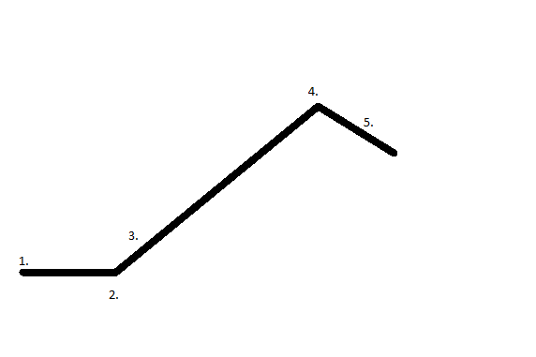

1.

2.

3.

4.

5.

