Kid Space - Character Sheets
(front)
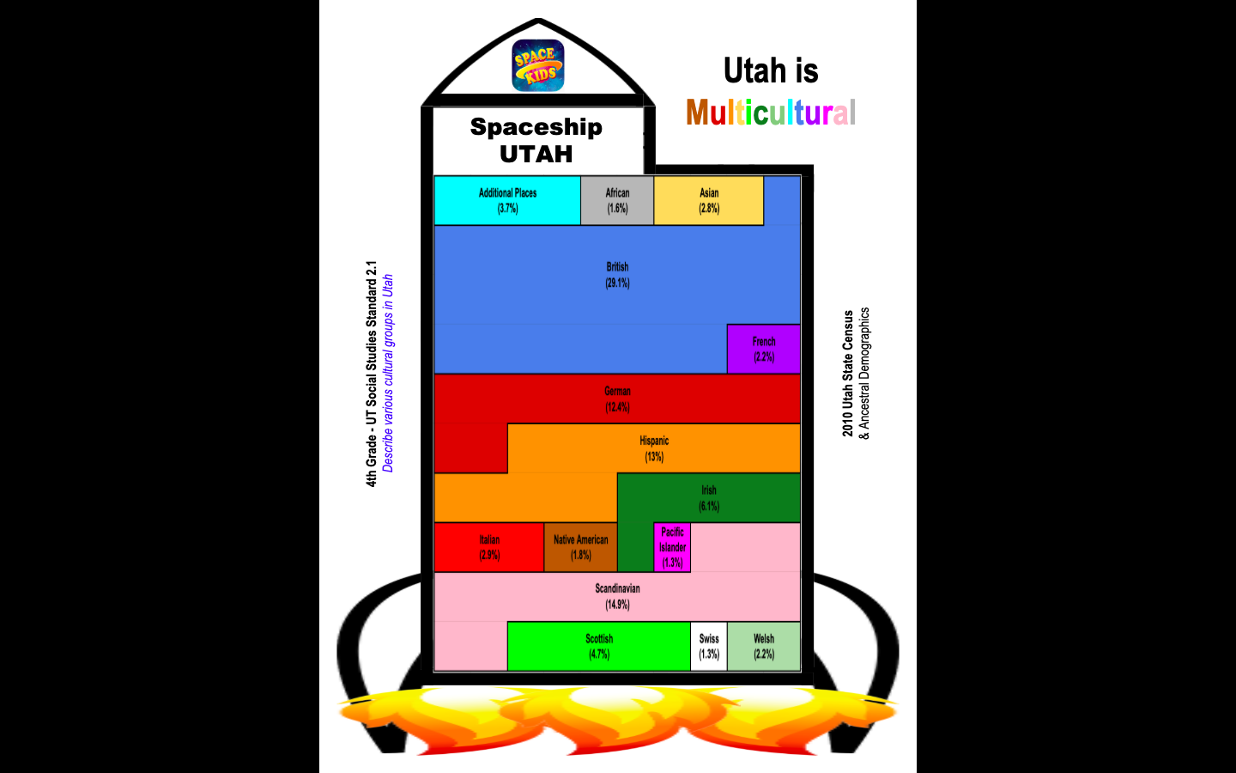
Kid Space - Character Sheets
(back)
