Lighting Research Handout

The purpose of this handout is to enhance the classroom lesson and provide more detailed information about stage lighting. It will help you gain a better understanding of theatrical lighting, the process, the fixtures, etc. It comes from several sources.

Please read through this material and retain it for your Production Book.

EXTRA CREDIT given for an oral report of this information and/or other (self-initiated) research.

Stage lighting
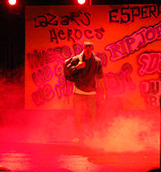

"Runaways" used conventional stage lighting and theatrical fog

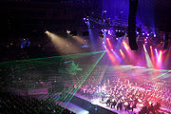
Classical Spectacular used ordinary stage lighting plus special laser effects
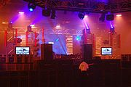
An example of a rig including moving head, generic and LED fixtures at 'The Tuesday Club'

Modern stage lighting is a flexible tool in the production of theatre, dance, opera and other performance arts. Several different types of stage lighting instruments are used in the pursuit of the various principles or goals of lighting.

Functions of lighting
Stage lighting has several functions, although to allow for artistic effect, no hard and fast boners can ever be applied. The functions of lighting include:
- Illumination: The simple ability to see what is occurring on stage. Any lighting design will be ineffective if the viewers cannot see the characters; unless this is the explicit intent.
- Revelation of form: Altering the perception of shapes onstage, particularly three-dimensional stage elements.
- Focus: Directing the audience's attention to an area of the stage or distracting them from another.
- Mood: Setting the tone of a scene. Harsh red light has a totally different effect than soft lavender light.
- Location and time of day: Establishing or altering position in time and space. Blues can suggest night time while orange and red can suggest a sunrise or sunset. Use of gobos to project sky scene, moon etc
- Projection/stage elements: Lighting may be used to project scenery or to act as scenery onstage.
- Plot: A lighting event may trigger or advance the action onstage.
- Composition: Lighting may be used to show only the areas of the stage which the designer wants the audience to see, and to "paint a picture".
While Lighting Design is an art form, and thus no one way is the only way, there is a modern movement that simply states that the Lighting Design helps to create the environment in which the action take place while supporting the style of the piece. "Mood" is arguable while the environment is essential.

Qualities of lighting
The four main qualities or properties of lighting are intensity, color, pattern and focus.

Intensity
Measured in lux, lumens and foot-candles. For any given luminaire (lighting instrument or fixture), this depends upon the power of the lamp, the design of the instrument (and its corresponding efficiency), the presence or absence of color gels or gobos, distance from the area to be lit and the beam or field angle of the fixture, the color and substance to be lit, and the neuro-optics of the total scene (that is, the relative contrasts to other regions of illumination).

Color
Color temperature is measured in Kelvin, and gel colors are organized by several different systems maintained by the color manufacturing companies. The apparent color of a light is determined largely by the gel color given it, but also in part by the power level the lamp is being run at and the color of material it is to light. As the percentage of full power a lamp is being run at drops, the tungsten filament in the bulb glows orange instead of more nearly white. This is known as amber drift or amber shift. Thus a 1000-watt instrument at 50% will appear far more orange than a 500-watt instrument at full.
LED fixtures create color through additive color mixing with red, green, and blue LEDs at different intensities. This type of color mixing is also used frequently with border lights and cyclorama lights to create different colors on stage and on the cyclorama. Another form of color mixing is CMY, or subtractive color mixing. Cyan, magenta and yellow dichroic filters are used in different percentages to create different colors. Because it is often difficult to create true reds and greens, a green dichroic filter is often added to fixtures using this method of colour mixing.

Pattern
 | 
A gobo of this shape in a fixture with a red gel would produce a pattern like the one shown to the right.
Pattern refers to the shape, quality and evenness of a lamp's output. The pattern of light an instrument makes is largely determined by three factors. The first are the specifics of the lamp, reflector and lens assembly. Different mounting positions for the lamp (axial, base up, base down), different sizes and shapes of reflector and the nature of the lens (or lenses) being used can all affect the pattern of light. Secondly, the specifics of how the lamp is focused affect its pattern. In ellipsoidal reflector spotlights (ERS) or profile spotlights, there are two beams of light emitted from the lamp. When the cones of both intersect at the throw distance (the distance to the stage), the lamp has a sharply defined 'hard' edge. When the two cones do not intersect at that distance, the edge is fuzzy and 'soft'. Depending on which beam (direct or reflected) is outside the other, the pattern may be 'thin and soft' or 'fat and soft.' Lastly, a gobo or break up pattern may be applied to ERSs and similar instruments. This is typically a thin sheet of metal with a shape cut into it. It is inserted into the instrument near its aperture. Gobos come in many shapes, but often include leaves, waves, stars and similar patterns.

Focus, position, and hanging
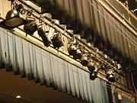
Many stage lights hung on a batten focused in several directions

Focus is a term usually used to describe where an instrument is pointed. The final focus should place the "hot spot" of the beam at the actor's head level when standing at the center of the instrument's assigned "focus area" on the stage. Position refers to the location of an instrument in the theater's fly system or on permanent pipes in front-of-house locations. Hanging is the act of placing the instrument in its assigned position.
In addition to these, certain modern instruments are automated, referring to motorized movement of either the entire fixture body or the movement of a mirror placed in front of its outermost lens. These fixtures and the more traditional follow spots add Direction and Motion to the relevant characteristics of light. Automated fixtures fall into either the moving head or moving mirror / scanner category. Scanners have a body which contains the lamp, PCBs, transformer, and effects (color, gobo, iris etc.) devices. A mirror is panned and tilted in the desired position by pan and tilt motors, thereby causing the light beam to move. Moving head fixtures have the effects and lamp assembly inside the head with transformers and other electronics in the base or external ballast. There are advantages and disadvantages to both. Scanners are typically faster and less costly than moving head units but have a narrower range of movement. Moving head fixtures have a much larger range of movement as well as a more natural inertial movement but are typically more expensive.
The above characteristics are not always static, and it is frequently the variation in these characteristics that is used in achieving the goals of lighting.
Stanley McCandless was perhaps the first to define controllable qualities of light used in theater. In A Method for Lighting the Stage, McCandless discusses color, distribution, intensity and movement as the qualities that can be manipulated by a lighting designer to achieve the desired visual, emotional and thematic look on stage. The McCandless Method, outlined in that book, is widely embraced today. The method involves lighting an object on the stage from three angles- 2 lights at 45 degrees to the left and right, and one at 90 degrees (perpendicular to the front of the object).

Lighting professionals

The lighting designer
The above elements of lighting are primarily the domain of the Lighting Designer (LD). The LD is responsible for using the principles above to achieve "the lighting look" — using lighting to affect the audience's senses and evoke their emotions. The lighting designer is familiar with the various types of lighting instruments and their uses. In consultation with the director and the scenic designer, and after watching sufficient rehearsals, the LD is responsible for providing an Instrument Schedule and a Light Plot. The Schedule is a list of all required materials, including color gel, gobos, color wheels, barn doors and other accessories. The light plot is typically a plan view of the theatre in which the performance will take place, with every luminaire marked. This typically includes approximate focus (the direction it should be pointing), a reference number, any accessories required, and the specifics (or channel number) of its connection to the dimmer system or lighting control console.^{[12]}
A LD must be accustomed to working around the demands of the director or head planner. Practical experience is required to know the effective use of different lighting instruments and color in creating a design. Many designers start their careers as lighting technicians in theatres or amateur theatre groups. Often, this is followed by training in one of the many vocational colleges or universities around the world that offer theatre courses. Many jobs in larger venues and productions require a degree from a vocational school or college in theatrical lighting, or at least a bachelor’s degree.

Other positions
In theater: Master Electrician/Chief Electrician;
Production Electrician;
Lighting Programmer;
Lighting Operator/Light board operator
In film: Best boy (electrical);
Gaffer (motion picture industry)
In music: Rigger

Lighting instruments
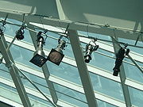
Source Fours in use at the United States Marine Corps museum

In the context of lighting design, a lighting instrument (also called a luminaire) is a device that produces controlled lighting as part of the effects a lighting designer brings to a show. The term lighting instrument is preferred to light to avoid confusion between light and light sources.
There are a variety of instruments frequently used in the theater. Although they vary in many ways they all have the following four basic components in one form or other:
- Box/Housing - a metal or plastic container to house the whole instrument and prevent light from spilling in unwanted directions.
- Light Source (lamp).
- Lens or opening - the gap in the housing where the light is intended to come out.
- Reflector - behind or around the light source in such a way as to direct more light towards the lens or opening.
Additional features will vary depend on the exact type of fixture.
Most theatrical light bulbs (or lamps, the term usually preferred) are Tungsten-Halogen (or Quartz-Halogen), an improvement on the original incandescent design that uses a halogen gas instead of an inert gas to increase lamp life and output. Fluorescent lights are rarely used other than as work lights because, although they are far more efficient, they cannot be dimmed (run at less than full power) without using specialized dimmer ballasts and they will not dim to very low levels. They also do not produce light from a single point or easily concentrated area, and have a warm-up period, during which they emit no light or do so intermittently. High-intensity discharge lamps (or HID lamps), however, are now common where a very bright light output is required, - for example in large follow spots, HMI (Hydrargyrum medium-arc iodide) floods, and modern automated fixtures. When dimming is required, it is done by mechanical dousers or shutters, as these types of lamps also cannot be electrically dimmed.
Most instruments are suspended or supported by a "U" shaped yoke, or 'trunion arm' fixed to the sides of the instrument, normally near its center of gravity. On the end of such, a clamp (known as a hook-clamp, C-clamp, or pipe clamp - pipe referring to battens) is normally fixed, made in a "C" configuration with a screw to lock the instrument onto the pipe or batten from which it is typically hung. Once secured, the fixture can be panned and tilted using tension adjustment knobs on the yoke and clamp. An adjustable c-wrench (US) or spanner (UK) is often used to assist the technician in adjusting the fixture.
All lights are loosely classified as either floodlights (wash lights) or spotlights. The distinction has to do with the degree to which one is able to control the shape and quality of the light produced by the instrument, with spotlights being controllable, sometimes to an extremely precise degree, and floodlights being completely uncontrollable. Instruments that fall somewhere in the middle of the spectrum can be classified as either a spot or a flood, depending on the type of instrument and how it is used. In general, spotlights have lenses while floodlights are lense-less, although this is not always the case.
Traditionally theatre and stage lighting has been of the "generic" type. These are lights which are focused, gelled, and then simply dimmed to give the effect the designer wants. In recent years the emergence of moving lights (or automated lights) has had a substantial impact of theatre and stage lighting.
A typical moving light allows the designer to control the position, color, shape, and strobing of the light beam created. This can be used for exciting effects for the entertainment or dance floor use. Moving lights are also often used instead of having a large number of "generic" lights. This is because one moving light can do the work of several generics.
Please note: In the UK the nomenclature is slightly different from North America. This article primarily uses the North American terminology. Although there is some adoption of the former naming conventions it has been normal to categorize lanterns by their lens type, so that what in the US is known as a spotlight is known as a Profile or a Fresnel/PC (Pebble/Plano/Prism Convex) in the UK. A Spotlight in the UK often refers to a Followspot. The following definitions are from a North American point of view, and would be confusing when used, without further clarification, in the UK. UK naming conventions are considered to be correct in most of the world, in fact most North American theatres will also use the UK terms except when talking in a more general sense (ie get a spotlight to focus on that set piece, or 'flood this area')
Also note: In Australia and many other places, the lamps inside a theatrical fixture are referred to as bubbles. In North American English, a bubble refers to the protrusion that occurs when one's body (or other oily substance) contacts the lamp. Oil will cause the portion of the lamp which has oil on it to expand when it is on (lamps generate a lot of heat), creating the bubble, and causing the lamp to explode. That is why one should never directly touch the glass portion of a lamp. Cleaning with rubbing alcohol will remove the oil.

Lighting controls
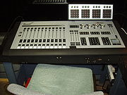
Entertainment Technology's Marquee lighting console.

Lighting control tools might best be described as anything that changes the quality of the light. Historically this has been done by the use of intensity control. Technological advancements have made intensity control relatively simple - solid state dimmers are controlled by one or more lighting controllers. Controllers are commonly lighting consoles designed for sophisticated control over very large numbers of dimmers or luminaires, but may be simpler devices which play back stored sequences of lighting states with minimal user interfaces. Consoles are also referred to as lighting desks or light-boards.
For larger shows or installations, multiple consoles are often used together and in some cases lighting controllers are combined or coordinated with controllers for sound, automated scenery, pyrotechnics and other effects to provide total automation of the entire show. See show control.
The lighting controller is connected to the dimmers (or directly to automated luminaires) using a control cable (e.g. DMX512) or network, allowing the dimmers which are bulky, hot and sometimes noisy, to be positioned away from the stage and audience and allowing automated luminaires to be positioned wherever necessary. In addition to DMX512, newer control connections include RDM (Remote Device Management) which adds management and status feedback capabilities to devices which use it while maintaining compatibility with DMX512; and ACN (Architecture for Control Networks) which is a fully featured multiple controller networking protocol. These allow the possibility of feedback of position, state or fault conditions from units, whilst allowing much more detailed control of them.

Dimming
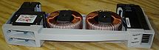
A pair of modern 2.4k dimmers by Electronic Theatre Controls
A dimmer is a device used to vary the electrical power delivered to the instrument’s lamp. As power to the lamp decreases, the light fades or dims. It is important to note that some color change also occurs as a lamp is dimmed, allowing for a limited amount of color control through the dimmer. Fades can be either UP or DOWN, that is increasing or decreasing the intensity. Today, most dimmers are solid state, although many mechanical dimmers still exist.

Theatrical Lighting Fixture Terminology
Ellipsoidals are generally fixed focus spotlights that produce a round, hard edged beam of light. The ellipsoidal shaped reflector, in combination with lenses sized from 3 to 8 inches, establish the various focal lengths. The fixture incorporates the use of shutters that can shape the beam of light. Ellipsoidals are also used for pattern or gobo projection. These fixtures are most often used for front of house and special lighting. |  | Fresnels are spotlights that produce a variable round, soft edged beam of light. This fixture can be focused from "Spot" to "Flood". Fresnels are most often used on stage for back, side or down lighting. The fixture will accept a wide range of lamps and accessories.
PAR fixtures are steel hoods which hold sealed beam lamps, producing an oval soft edged pool of light. PAR fixtures uses various type lamps that produce different beam shapes. PARS are one of the most cost efficient lighting fixtures in terms of multiple uses. There is no focusing adjustment on the PAR fixture. PAR fixtures are often used instead of fresnels and for broad color washes. |  | Scoop fixtures are large floodlights that produce a wide, diffused wash of light. Normal uses include large area color washes, general illumination and cyclorama lighting. The scoop has a matte finish ellipsoidal-shaped reflector and no lens.
Borderlights/Striplights  The Striplight is a multi-lamp fixture designed for even colored lighting on a stage or cyclorama. This fixture is normally wired in 3 or 4 circuits with one color per circuit often using permanent glass color filters called roundels. Roundels are available in red, blue, green, amber and pink. Cyc Lights are the modern improvement of the striplight. The cyc light has a special shaped reflector which produces a smooth field of light from top to bottom of the cyclorama. Cyc lights are available in one, two, three or four "cell" units designed to be installed overhead or free standing on the stage floor. |  | Automated lighting fixtures are commonly called moving lights, automated lighting and intelligent lights. By definition, all moving lights contain some method of animating the beam of light on ‘x’ and ‘y’ axis. This is accomplished by either a "moving mirror" design, in which a mirror at the end of the optical train moves to these x and y coordinates, or the "moving yoke," where the entire head of the fixture moves. All moving lights allow the color and beam definition to be altered electronically. Moving lights operate under USITT DMX512 control protocol and can be operated by any theatrical console utilizing DMX512.
Followspots are manually operated lighting fixtures with a sharp movable beam of light used to follow a performer on stage. Followspots produce a beam of light similar to ellipsoidals. Followspots are equipped with color changers, iris (for varying the size of the spot) and dowser. |  | A color scroller allows a conventional lighting fixture to provide a variety of colors
Dimmers are often found in large racks that draw large amounts of three-phase electrical power. The dimmers themselves are often removable modules that range from a 20-amp, 2.4 Kilowatt unit to a 50-amp or even a 100-amp unit. They can often be replaced by a Constant Power Module which is basically a 20- or 50-amp breaker in a dimming module casing. Constant Power Modules are used to supply non-dimming current to other electrical devices (like smoke machines, chain winches, or scenic motors). When a Constant Power Module is installed, the corresponding circuit is energized as long as the dimming pack is on, independent of the lighting console.
Increasingly, with the growth of digital technology, modern lighting instruments are available which allow remote control, not just of intensity, but of direction, color, beam shape, projected image, beam angle and a wealth of other effects. The ability to move an instrument ever more quickly and quietly has become the industry goal. Such automated lights frequently have built-in dimming and so are connected directly to the control cable or network and are independent of external dimmers.
FUNCTIONS OF STAGE LIGHTING
While most textbooks teach that there are four functions of stage lighting, some believe there are seven:
- Visibility: If the audience can't see the actors, everything else the lighting designer does is a waste of time. Studies have shown that visibility affects our ability to understand spoken speech. This doesn't mean that the audience must see everything all of the time; a German director named Max Reinhardt once said that, "The art of lighting the stage consists of putting light where you want it and taking it away from where you don't want it."
- Mood: (or "atmosphere") "Mood" is the evocation in the audience of the appropriate emotion. Many designers err in paying attention to mood to the point where visibility is sacrificed.
- Composition: The act of painting a picture, in this case, with light.
- Plausibility: Sometimes called "realism", but that's not always accurate, since not all plays - and certainly very few ballets, modern dance pieces, and operas - are realistic. It's the same quality that Stephen Colbert refers to as "truthiness".
- Reinforcement: What are we reinforcing? Everything.
  - We reinforce the playwright's text: In A Midsummer Night's Dream, Puck has the line, "And yonder shines Aurora's harbinger," meaning the dawn. The lighting designer can reinforce this by providing the first rays of dawn.
  - We reinforce the work or the set and costume designers:
    - We might use colors that flatter or complement those used by our colleagues.
    - If the sets and/or costumes are sculpted and lush, we might light them so as to highlight their 3-dimensionality.
- Revelation of Form: Decide on the level of 3-dimensionality you want the audience to see. In some productions, you might want a "flat" look; in others – particularly in dance – you might want a more sculpted look. A case could be made that revelation of form is part of composition or mood; however, it's important enough (in some productions, at least) to be a stand alone function.
- Punctuation: The blackout at the end of a climactic musical number! The slow fade to black....

A different list:
- Selective visibility: illumination and focus.
- Indication of time and place (and any other realistic details necessary). (if not given in the play, it is often a good idea to invent them.)
- Mood and atmosphere (often best conveyed through the realistic details you have invented; these are generally more specific and interesting than "blue for sad".)
- Creation or emphasis of rhythm and punctuation.
- Heightening effect of other visual elements of the production: set, costumes, mise en scene.
- Integrative function: brings all other aspects of the production (dead scenery and live actors) and unites them into one world.
- Just aesthetics - often there is a show where you don't have much to do besides illuminate, and another useful aim is to try and make it look prettier or more visually striking than it would have without your lighting, thus compelling audience attention more strongly and heightening the theatrical experience. It might be a simple comedy or ballet, and you might just want to frame it in nice color or throw some gobos on the cyc.
- To aid in conveying whatever message you, the director, the other creative artists are trying to get across. An example might be that you're doing Othello and the idea is to create a feeling of the evil in the world overcoming the forces of good, so you (and the set designer hopefully, but not always) would strengthen that impression with light by having everything generally bright at the start and closing in to more isolated areas with dark outside as the play progresses.
- Helping the actors! Actors are generally happy that the stage lighting shuts them off from the audience in a different world, but sometimes they may need extra help - it could be be as simple as some low-intensity light to help them find their way in the dark. Actors blinded by sidelights may be helped by having faint light on the floor; this is an absolute necessity for dancers en pointe.

QUALITIES OF LIGHT
These are the attributes of light which can be manipulated in order to fulfill the seven functions, above:
- Intensity
- Color
- Distribution: Essentially, where the light hits the stage and from what angles. If we have a blue light hitting the SL side of the stage, and a red light hitting SR, that's a matter of distribution. If we flood the whole stage with an even wash of blue light, that's distribution. If we have an actor isolated in a tight special, that's distribution.
- Movement: Any change in any of the other three qualities.
Another list:
- Intensity
- Distribution
- Angle
- Color
- Change and movement
- Visual quality of the light field (diffuse, soft edged, or even and hard, with or without a clear outline.)
- External look: beams cutting through smoke filled air.

REFLECTIONS AND REFLECTORS
There are four types of reflection:
- Specular Reflection changes the direction of a beam of light without otherwise appreciably altering the nature of beam. A mirror is a specular reflector.
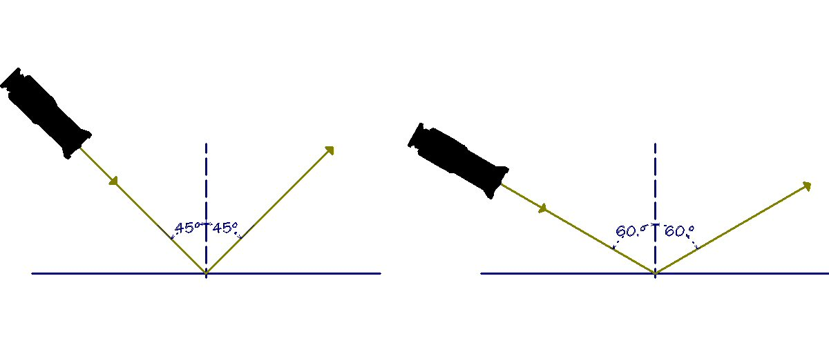
- Diffuse Reflection occurs when the beam of light is completely dispersed. The light bounces off the reflector in all directions. Example: flat paint.
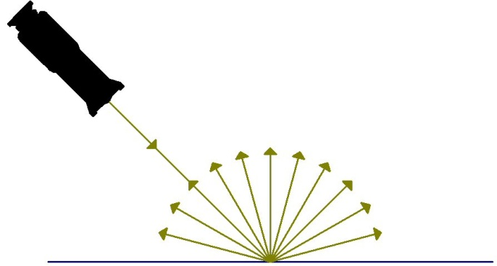
- Spread Reflection is similar to diffuse reflection, except that a greater percentage of the light is reflected along the angle of reflection than along any other line. Example: crumpled-up aluminum foil.
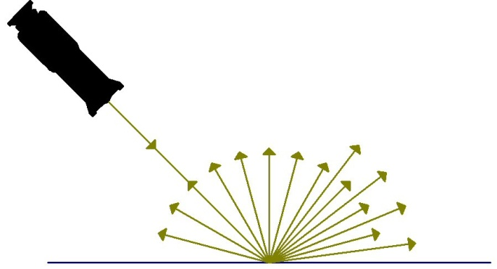
- Mixed Reflection is a mixture of diffuse and specular reflections. Examples: a doorknob / shiny wood floor /gold watch
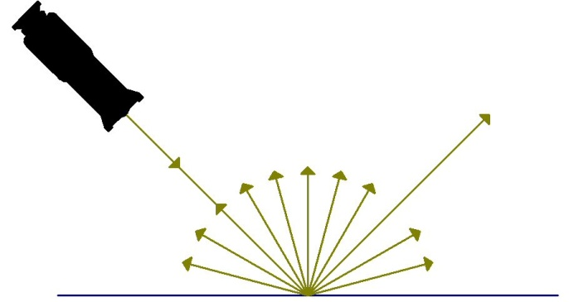
Why do we use reflectors in stage lights? Because if we didn't, the only light we'd get out of a stage lighting fixture would be the light radiated from the lamp in the direction of the stage. Since our goal is to achieve the highest level of efficiency, reflectors enable us to capture and use light beams which would otherwise be lost.
Stage lighting fixtures use several types of reflectors. Almost all use specular reflection. These are the most common:
ELLIPSOIDAL REFLECTOR | An ellipse is "a closed curve, generated by a point moving in such a way that the sum of its distances from two fixed points is constant." An ellipsoid is a 3-dimensional ellipse. An ellipsoidal reflector has two focal points; light rays originating at one focal point converge at the other. An ellipsoidal reflector is actually ½ of an ellipsoid.  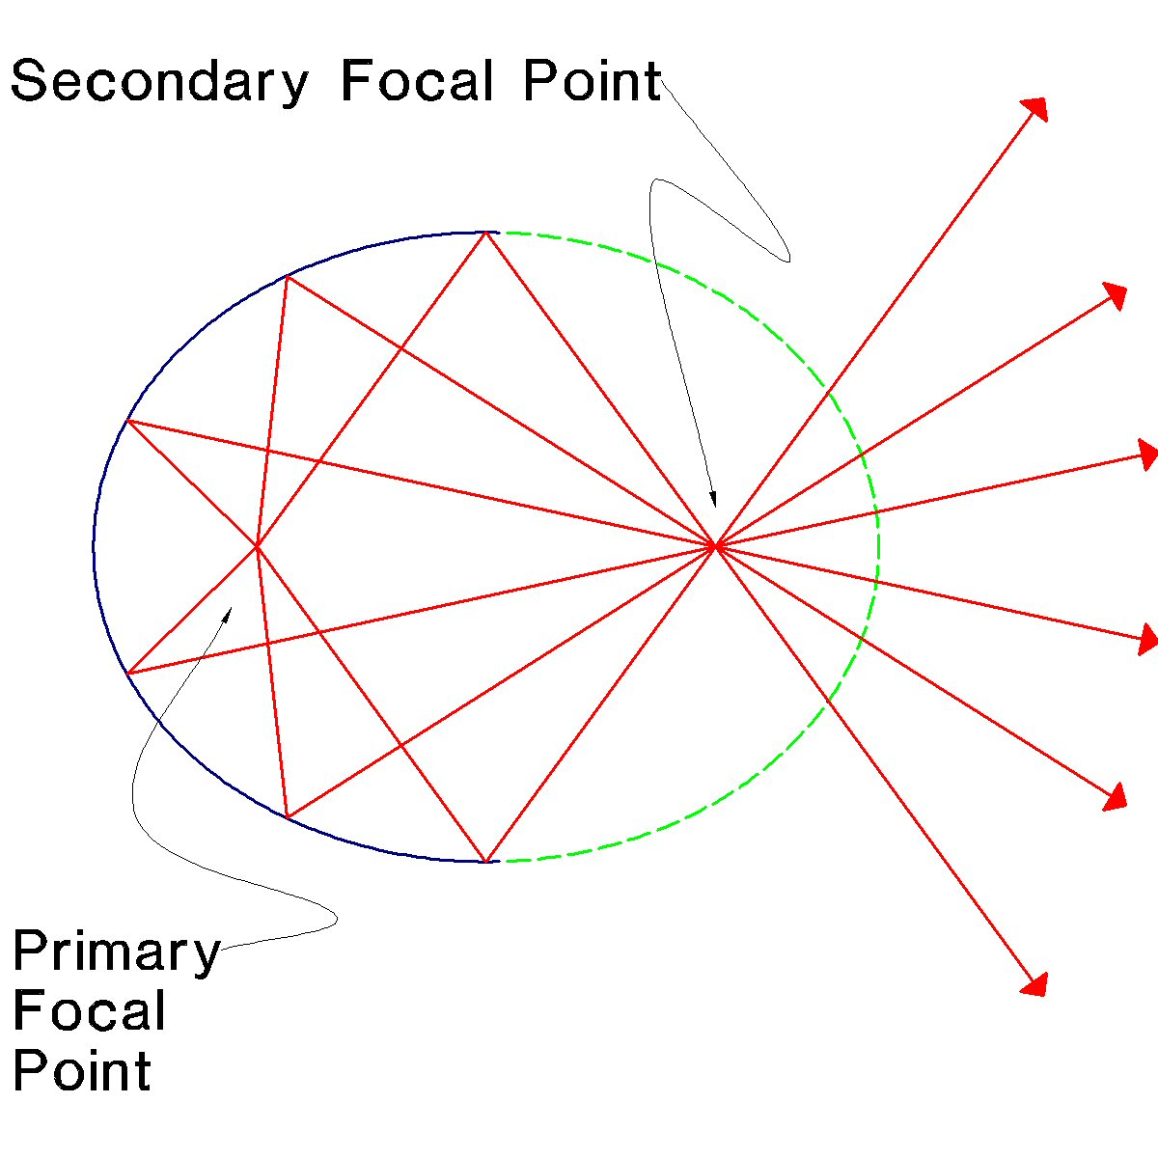
SPHERICAL REFLECTOR | Spherical reflectors reflect all beams which strike the reflector from or through the center of curvature back through the center of curvature. This is indicated by the red lines and arrows in the drawing below.  The focal point is at 1/2 the radius of the sphere. As with parabolic reflectors (see the section below), any beam that passes through the focal point and strikes the mirror will be reflected out in parallel rays. This is indicated by the amber lines and arrows in the drawing below.  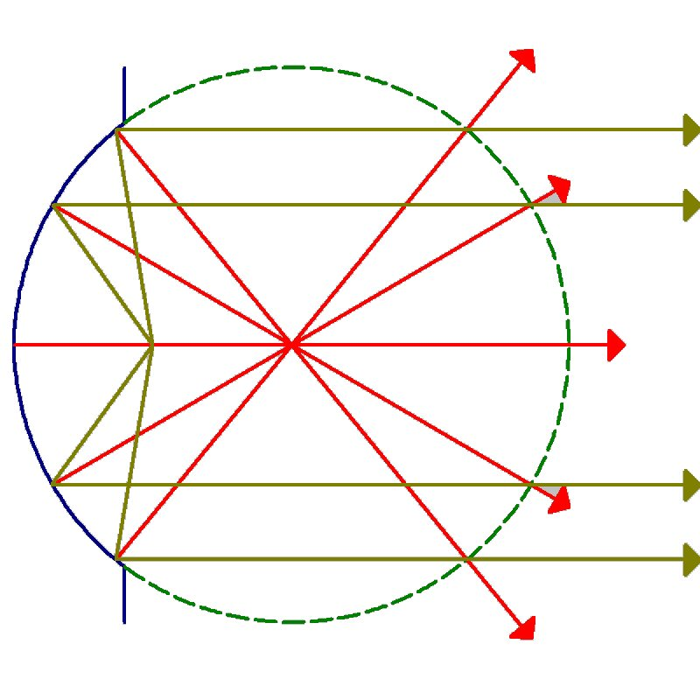
PARABOLIC REFLECTOR | Parabolic reflectors reflect all beams which strike the reflector from or through the focal point out parallel to each other in a beam of light approximately the diameter of the reflector. Example: searchlights, many hand-held flashlights/torches.  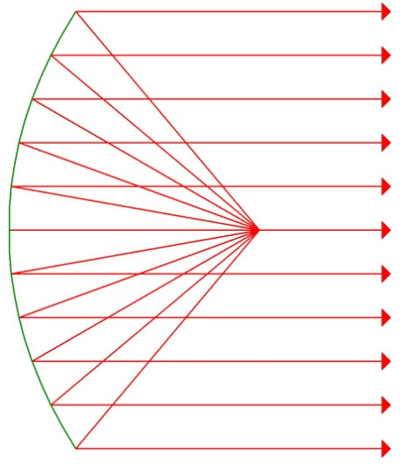

LENSES
PLANO-CONVEX  LENS: | A lens curved on one side and flat on the other. The more pronounced the curvature of the convex side, the closer to the lens will be the point at which light rays entering the lens from the convex side will converge. The distance from the lens to this point is called the focal length.  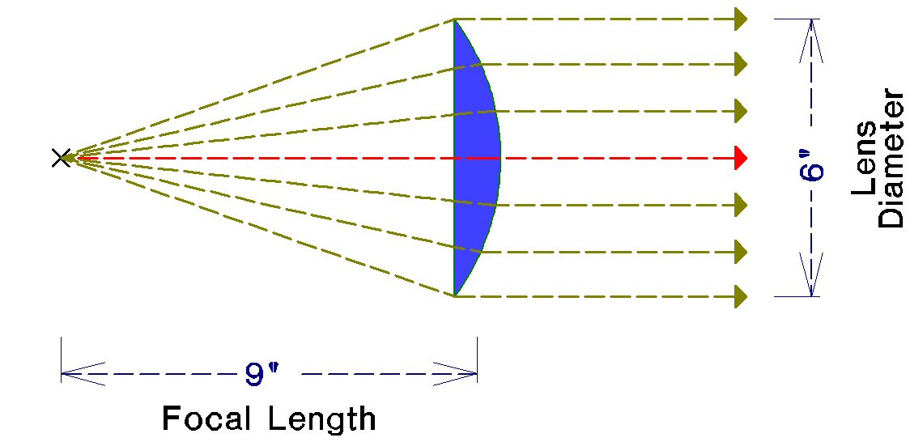  A plano-convex lens is described by its diameter and focal length. For example, a 6"x9" lens will have a diameter of 6" and a 9" focal length. The shorter the focal length, relative to the diameter of the lens, the wider the beam of light; thus, a 6"x12" lens will emit a beam of light 3/4 the width of the 6"x9" lens. When two plano-convex lenses are used "belly-to-belly", their effective combined focal length is halved. For example, two 6"x9" lenses belly-to-belly will have an effective focal length of 4½".  Fixtures using plano-convex lenses typically project sharp-edged images.

STEP LENS: | 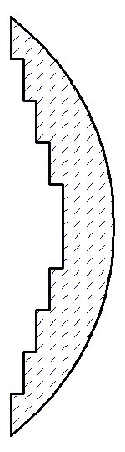  Plano-convex lenses with the flat side cut away in steps. Step lenses are optically similar to plano-convex lenses, but lighter and less prone to cracking from the heat. The light from a step lens is usually not as even as that from a plano-convex lens.

FRESNEL LENS: | Fresnel lenses, as opposed to step lenses, are cut away from the front. They are extremely thin and therefore efficient and less likely to crack from heat Unlike step lenses, each of which has a single focal length, each concentric ring of a Fresnel lens has a different diameter and a slightly different focal length. Fixtures using Fresnel lenses project soft-edged images.

EFFECTS OF DIFFERENT LIGHTING ANGLES
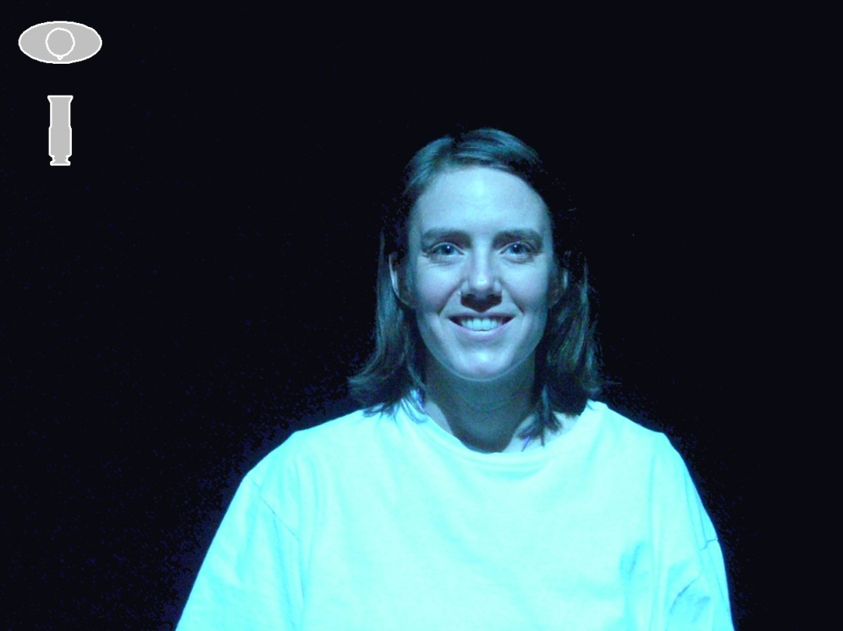 | 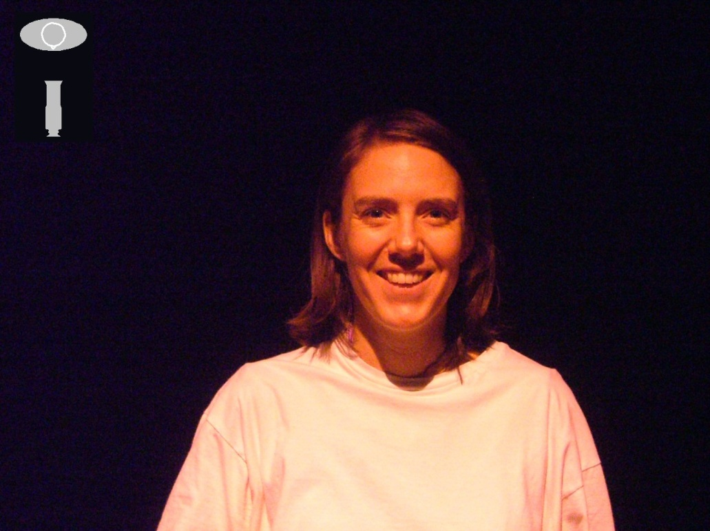
45° Up/Straight DS (Blue) | 45° Up/Straight DS (Pink)
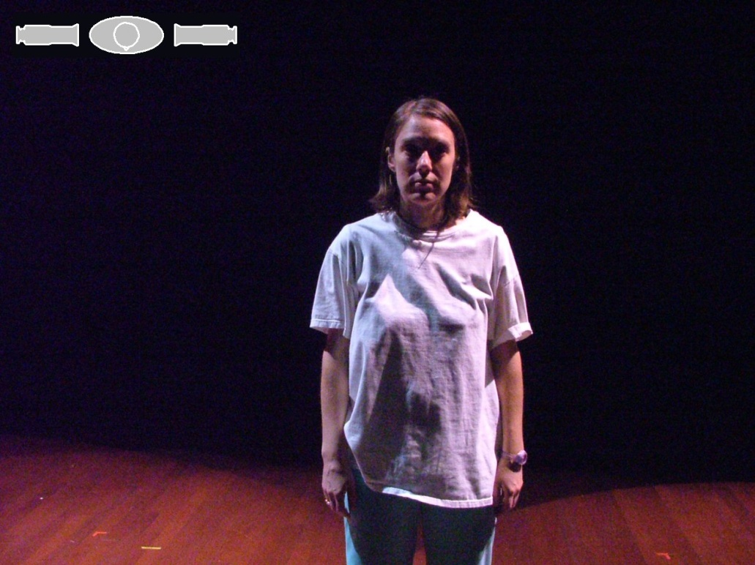
90° SL/90° SR
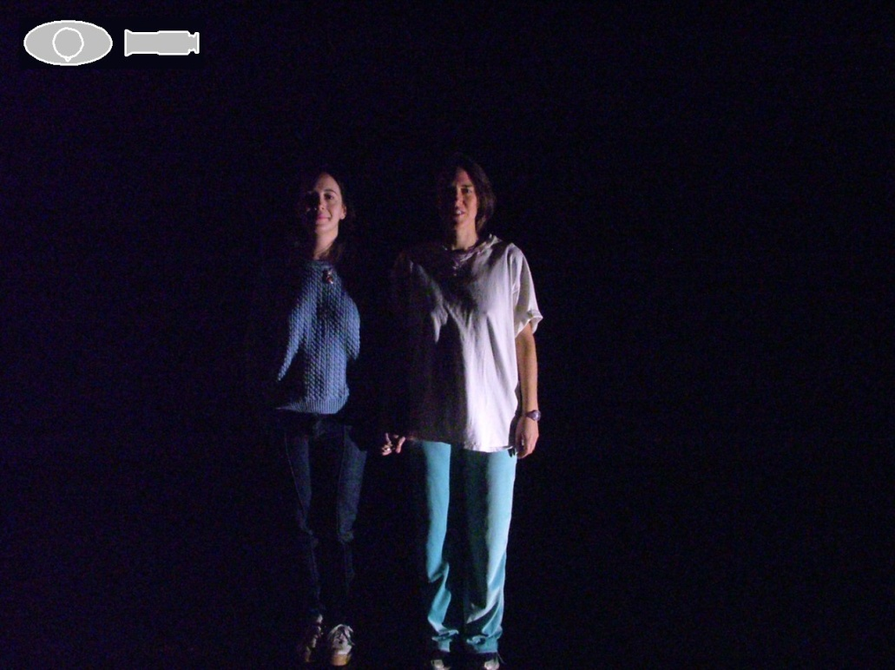 | 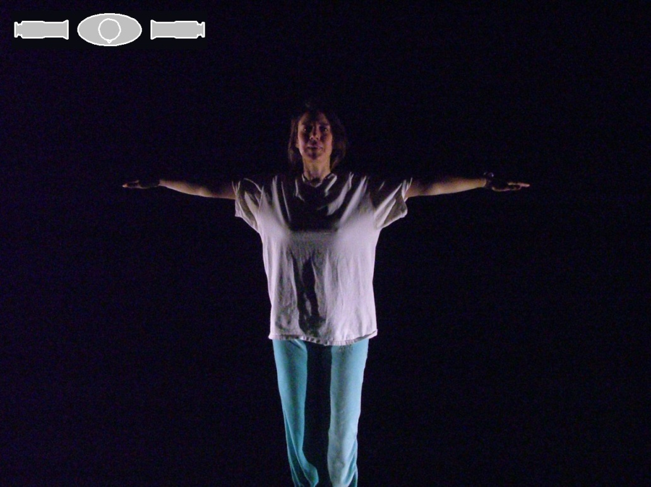
Shinbuster from SL | Shinbusters from SL and SR
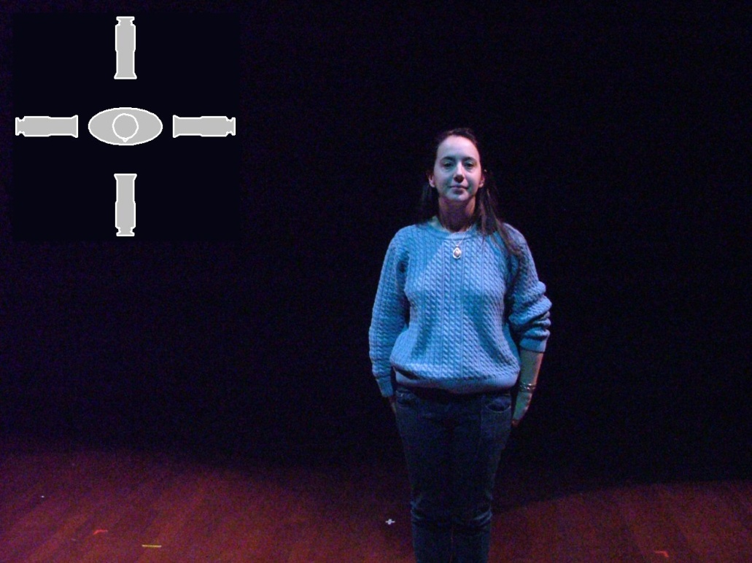 | 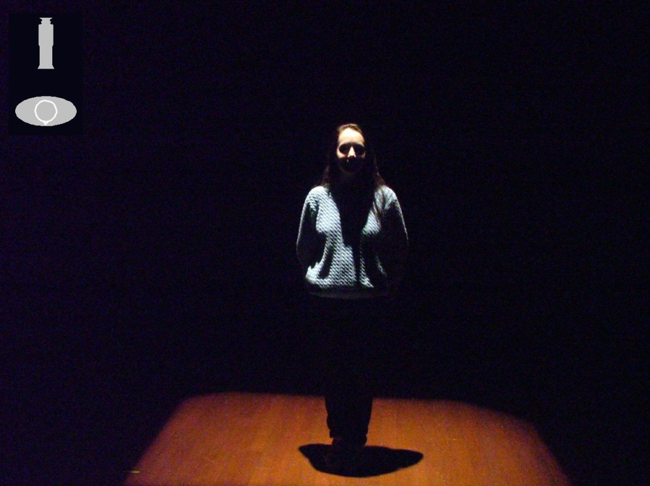
Straight DS/90° SL/90° SR/Straight US | Straight US
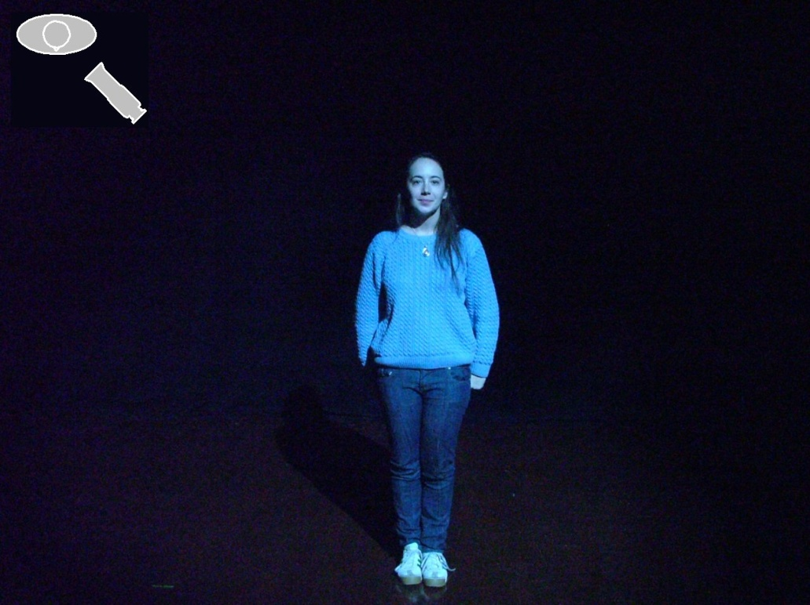 | 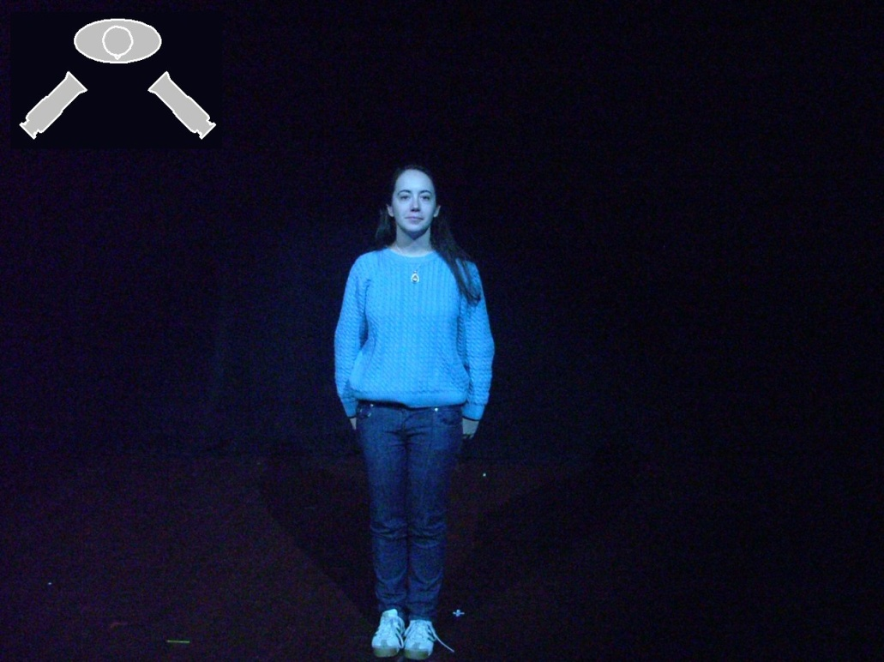
45° SL | 45° SL/45° SR -- Identical Colors
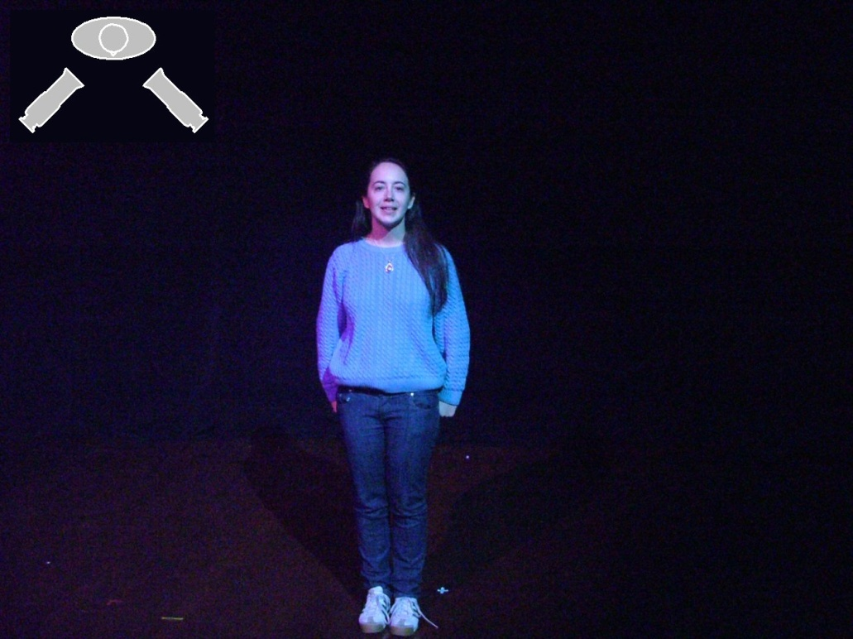
45° SL/45° SR -- Different Colors

PHOTOMETRICS
The field size of any lighting fixture can be calculated by multiplying the throw by the multiplication factor:
[Throw] x [mf] = [Field Size]
In the example below, the throw is 18' and the fixture's mf is .68, giving a field size of 12.24':
18 x 0.68 = 12.24
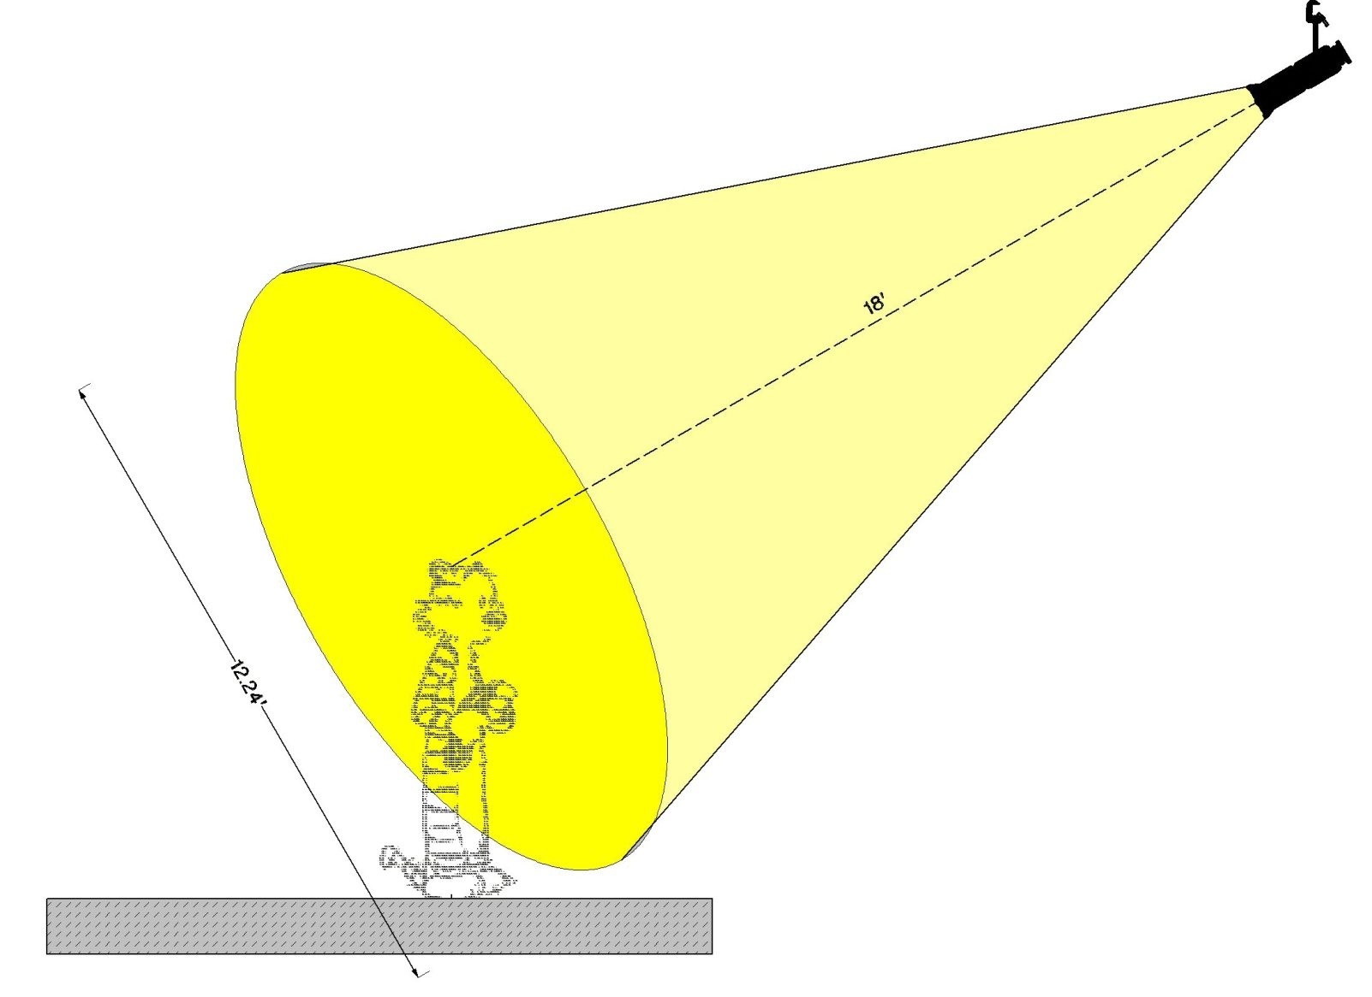
Remember that in most cases, we are basing our calculations on the distance between the fixture and the performer's face, rather than on the distance from the fixture to the floor.
A fixture's peak candela is its intensity, in lumens, as measured from right in front of the instrument, directly on its axis. Intensity is measured in footcandles, using the following formula:
[Peak Candela] / [Throw²] = [Footcandles]
Assuming that the fixture in the above example has a peak candela of 88,000, its intensity can be calculated thusly:
88,000 / 324 = 271.60
A fixture's peak candela and multiplication factor usually can be found in the data sheets provided by the manufacturer.

THE INVERSE SQUARE LAW
The inverse-square law, greatly simplified, states that the intensity of light (or any other radiant energy), if the light strikes the target at a right angle, varies inversely according to the square of the distance from the source.
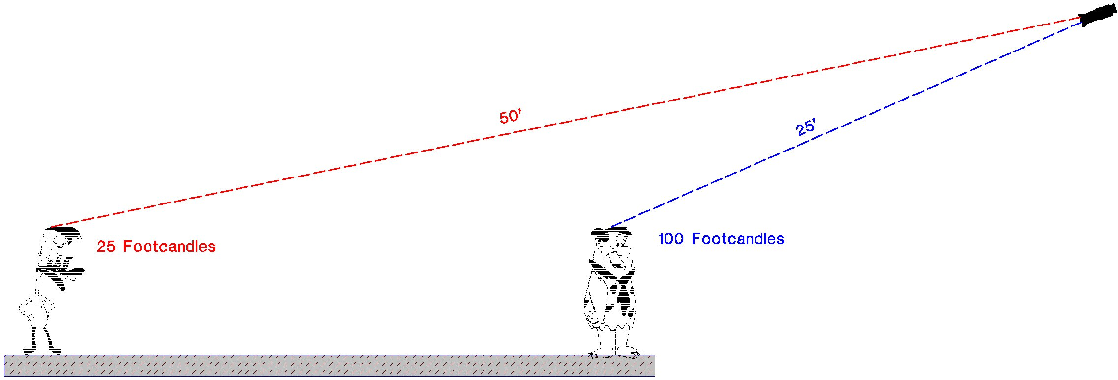
In other, simpler, words....
- In the example above, the light strikes Fred Flintstone at a 25' throw and its intensity is 100 footcandles.
- The throw to Duckman is 2 times as far. The square of 2 is 4 and the inverse of 4 is ¼.
- Therefore, the intensity of light on Duckman is 25 footcandles, because 25 is ¼ of the 100 footcandles striking Fred Flintstone.

ELECTRICAL FORMULAS
OHM'S LAW | A description of the relationship between voltage, current, and resistance, where:  - E stands for voltage (or "electromotive force")  - I stands for current, and  - R stands for resistance.  Ohm's Law is expressed thusly:  E = IR  So, if we know that our voltage is 120V and our current is 20A, we can calculate the resistance:  120 = 20xR  120/20 = 6  Therefore, our resistance is 6 ohms. Since the mathematical symbol for "ohm" is the Greek letter Omega, we write this answer as:  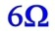
THE POWER EQUATION | Describes the relationship between wattage, current, and voltage, where:  - E stands for voltage (or "electromotive force")  - I stands for current, and  - P stands for wattage (or "power")  Because of these symbols, the Power Equation is often referred to as the "PIE" formula:  P=IE  If, as in the above example, our voltage is 120V and our current is 20A, we can use the Power Equation to calculate the wattage:  P = 20 x 120  20 x 120 = 2400  ...So our power is 2400W.  If, however, our voltage is 240V and our current is 10A, the equation looks like this:  P = 10 x 240  10 x 240 = 2400  ...So our power is still 2400W.  The Power Equation is also known as the "West Virginia" formula, because it can also be expressed with these symbols:  W=VA

SAFETY
A detailed discussion of theatrical safety is beyond the scope of this website; however, we urge you to read the several good books on this topic, especially those written by Dr. Randall ("Doctor Doom") Davidson, and to remember that:
- You are neither invulnerable nor immortal. Really.
- If you can't afford to do it safely, you can't afford to do it.
- If you tell the emergency room physician, "We didn't have the time and money to do it right," she's not then going to say, "Oh, OK, in that case, he's not dead."

Curtains, Track & Rigging: In addition to design, manufacture and installation services Mainstage offers consultations, safety inspections, and repairs on your curtain, track or rigging system. Curtains are custom manufactured in our shops by seasoned professionals using the highest quality products. Full track and hardware packages are available for manual or motorized operation as well as complete stage, television and arena rigging systems, fire protection installations and upgrades. We use track and rigging components manufactured specifically for theatrical use, sized to your specifications. Mainstage offers the sale of the individual track and rigging products or the utilization of our own crew for turn-key installations. | 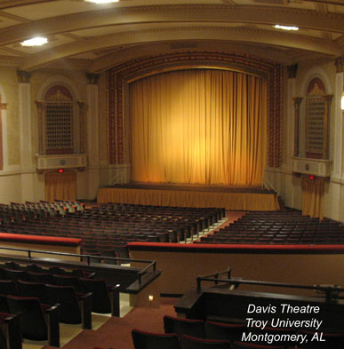

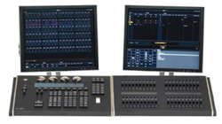 | .  Basic Lighting and Dimming services include but are not limited to; the supply of small to large lighting systems including our expert supervision of the installation and on-site maintenance and training; consultation services from basic recommendations to written specifications and CAD drawings; and complete design and installation of all entertainment related equipment provided on a design/build basis or as a specialty contractor.
Lighting, Dimming and Control: Mainstage has always offered the latest in entertainment technology; in 1982, we were one of the first to bring digital dimming to the Wisconsin marketSince then we have provided installation of lighting and dimming systems across the nation. Our projects range from very small venues to new construction and renovations to complicated interfaces of control consoles.  Mainstage's experience in integrating lighting systems (dimming and control, fixtures, moving lights, etc.) with custom curtain and rigging systems allows us to provide our customers with a complete theatre system. We also provide replacement, upgrade or add-on parts for existing systems. Mainstage services what we sell, with authorized factory technicians in all of our locations.
  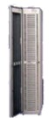
  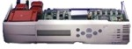
  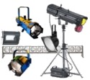

Consumables: Mainstage furnishes any product normally consumed during a production. With a vast number of high quality product lines from leading industry manufacturers, Mainstage is a full line supplier of lamps, stage and lighting hardware, fabric, patterns, gel, tape, paint, effects fluids and scenery products. | 