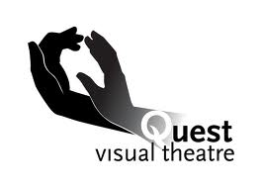
.

Quest Visual Theatre Proposal
Quest Visual Theatre was founded in 1997 in Lanham, Maryland as an inclusive theatre group that hires both hearing and deaf/hard of hearing actors. The theatre pieces are meant to be compelling for both hearing and deaf/hard of hearing audiences. They explore themes that are interesting and universal.
Core belief: Anything is possible
Core values: diversity, challenge, listen, achieve and have fun

Group Names:

- Give a brief synopsis of the story you as a group want to tell with your Visual Theatre piece.

- Describe the theme in that story that the group is interested in exploring.

- Describe what could be visually interesting about this theme and story.

- How does this story and theme fit in with the core belief and core values of Quest Visual Theatre?

- Why should Quest Visual Theatre consider your piece as a potential part of their repertoire?

