Rehearsal Stations
Group Members:_________________________________________

Title:_________________________________________________
Station #1: Characters
_________________ will be playing _____________________________.
_________________ will be playing _____________________________.
_________________ will be playing _____________________________.
_________________ will be playing _____________________________.
_________________ will be playing _____________________________.

_________________ will be playing _____________________________.

Station #2: Theme and Concept
Theme: __________________________________________
Concept: ________________________________________
How does your chosen concept support the theme?
_______________________________________________________
What do you need to change in your story so that the story flows better within your chosen concept?
_______________________________________________________
_______________________________________________________


Station #3: Story Structure

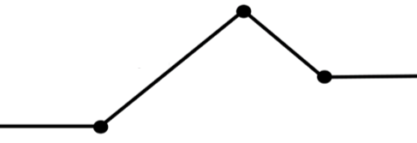


Station #4: Outline and Length
Time: _______________
We need to (circle one) ADD SUBTRACT KEEP.
We will work these three plot points in order to do so:
1._____________________________________________________

2._____________________________________________________

3._____________________________________________________

Station #5: Body and Voice
(Check the boxes once you have completed each task.)
- We discussed what voices we are going to use for our roles.
- We discussed how we will move our bodies in order to best portray the story.
We ran through as much of our story as possible using the body and voices we discussed.

